**Smart Traffic Management**

Design:

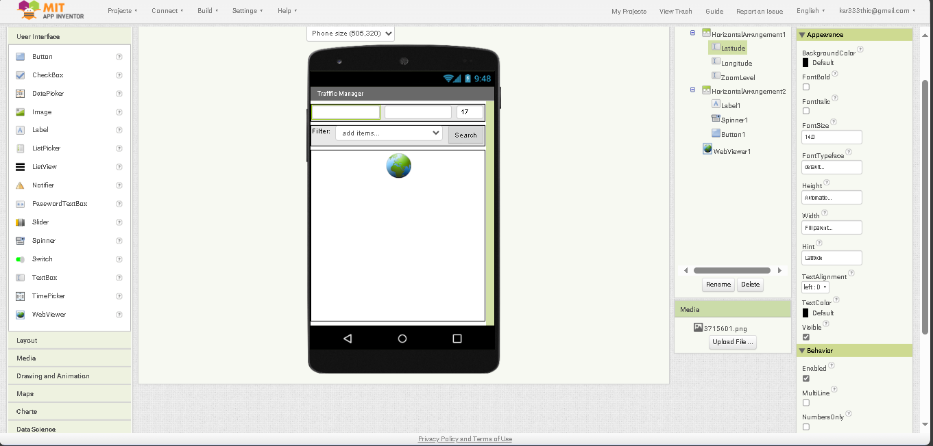

The ever-increasing challenges associated with urban traffic congestion necessitate innovative solutions to enhance traffic management and improve the overall transportation experience. This abstract provides an overview of the development of a mobile application designed to address these issues by monitoring and managing traffic in real-time through software technology.

Our project focuses on the creation of a comprehensive Traffic Management App (TMA) that leverages state-of-the-art software solutions. The TMA aims to provide a user-friendly interface that allows both traffic authorities and commuters to access real-time traffic data and make informed decisions. The key features of the TMA include:

1. Real-time Traffic Monitoring: The application employs GPS and sensor data to provide live traffic updates, including congestion, accidents, and road closures.

2. Traffic Flow Optimization: The TMA offers suggestions for optimizing routes and schedules, minimizing travel time, and reducing fuel consumption.

3. Incident Reporting: Users can report incidents such as accidents, road damage, or traffic violations, enabling quicker response from authorities.

4. Integration with Traffic Signals: The TMA can connect with traffic signals to prioritize traffic flow during peak hours or emergencies.

5. Data Analytics: The app utilizes big data analytics to predict traffic patterns and offer alternative routes, thus reducing congestion.

6. Communication and Alerts: Users receive real-time alerts and notifications about traffic conditions, route changes, or emergencies.

The Traffic Management App not only empowers commuters with real-time traffic information but also enables traffic authorities to proactively manage and optimize traffic flow. This abstract highlights the significance of this technology in enhancing urban mobility, reducing traffic-related stress, and contributing to a more sustainable urban environment.

The development and implementation of the Traffic Management App underscore the potential of software-driven solutions to revolutionize traffic management and improve the quality of life in urban areas. This project exemplifies the synergy of software technology and transportation management, ushering in a new era of smarter, more efficient traffic solutions.

**Blocks:**

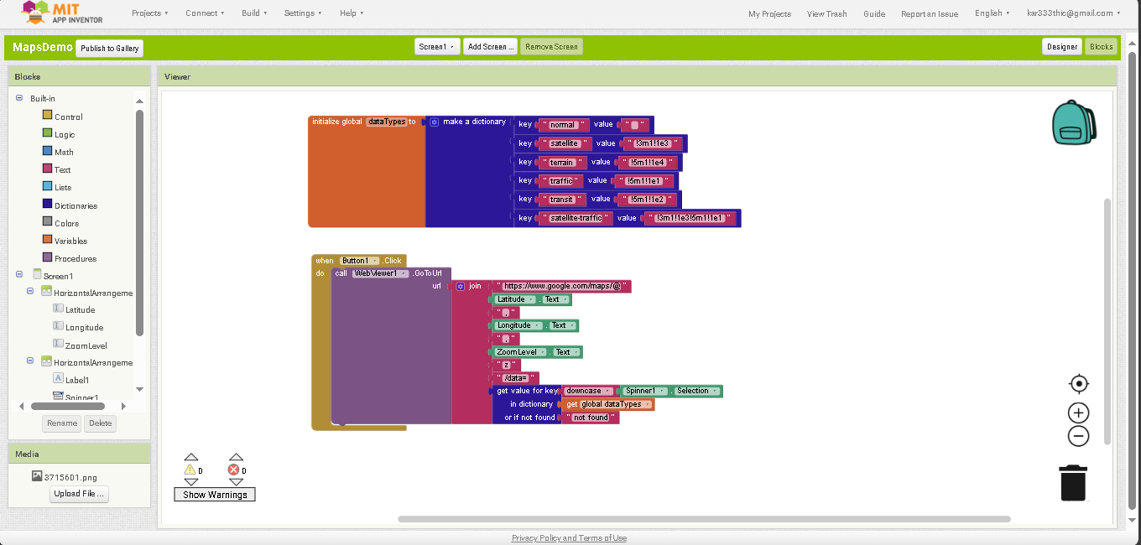

This abstract outlines the core concept and significance of creating blocks within MIT App Inventor to build a Traffic Management System (TMS) focused on real-time congestion monitoring and data integration, with the goal of transmitting critical traffic information into software applications.

The project at hand involves the development of a Traffic Management System, which utilizes MIT App Inventor, a user-friendly platform for building Android applications. The primary objective of this initiative is to design and integrate functional blocks that facilitate the real-time monitoring of traffic congestion, followed by the seamless transmission of this vital information into software systems for analysis, decision-making, and improved traffic management.

Key components and functionalities of the Traffic Management System include:

1. *Data Collection Blocks*: In the initial phase, we establish a network of data collection blocks that capture real-time traffic data from various sources, such as traffic cameras, sensors, GPS, and user-generated reports.

2. *Data Integration Blocks*: These blocks serve as the foundation for aggregating, filtering, and harmonizing the incoming traffic data, ensuring consistency and reliability.

3. *Congestion Detection Blocks*: We implement intelligent algorithms and decision-making logic to assess the traffic data and identify congestion points on roadways.

4. *Software Integration Blocks*: Once congestion is detected, the system uses software integration blocks to transmit this information into software applications used by traffic authorities, navigation apps, and commuters.

5. *User Engagement Blocks*: The system includes user engagement blocks that allow commuters to access real-time traffic updates, receive alerts, and provide incident reports, promoting user participation in the congestion monitoring process.

6. *Analytics and Decision Support Blocks*: The TMS incorporates analytical blocks that enable authorities to analyze traffic data trends, assess congestion causes, and make data-driven decisions for traffic management.

This initiative underscores the critical role of MIT App Inventor in simplifying the development process for complex systems like the Traffic Management System. By creating and integrating these blocks, we aim to empower traffic authorities and commuters with timely, accurate, and actionable traffic information. The seamless transmission of congestion data into software applications enhances urban mobility, reduces congestion-related delays, and supports sustainable transportation solutions.

In conclusion, the development of blocks within MIT App Inventor is fundamental to the success of the Traffic Management System, bridging the gap between data collection and effective software-based traffic management. This project epitomizes the synergy of user-friendly app development tools and innovative traffic solutions, ultimately contributing to more efficient and informed urban transportation.

Download link:

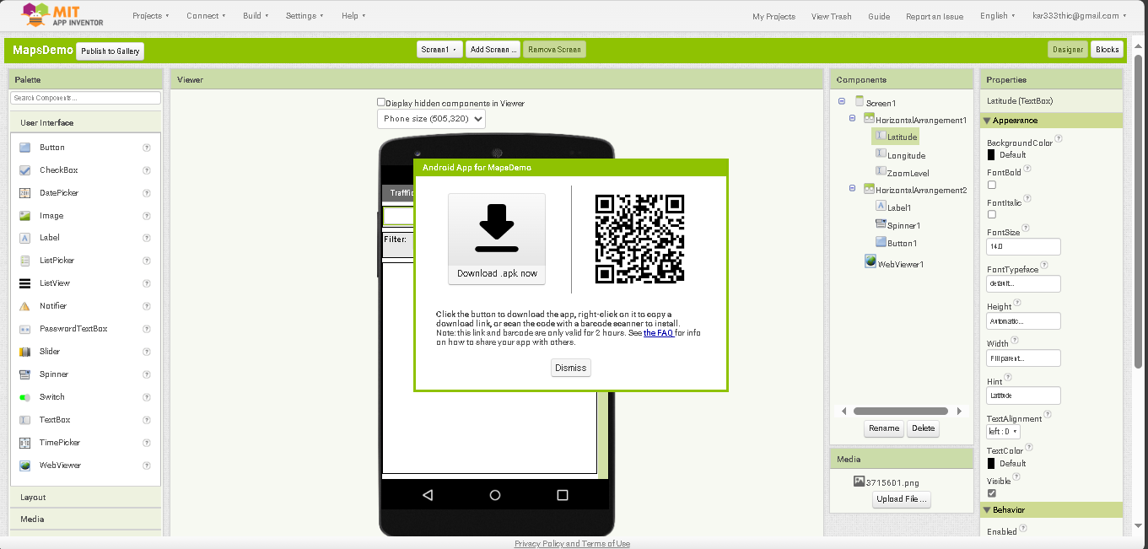

This abstract provides an overview of the process of downloading the MIT App designed for monitoring the Traffic Management System (TMS), highlighting its user-friendly features and the critical role it plays in enhancing traffic management and commuter experience.

The Traffic Management System (TMS) is a cutting-edge solution for addressing the growing challenges of urban traffic congestion. Developed using MIT App Inventor, the TMS app empowers both traffic authorities and commuters with real-time traffic data and smart features for better decision-making and congestion management.

Key aspects of the TMS app download process include:

1. *User Accessibility*: The MIT App for TMS is easily accessible to Android users through various channels, such as app stores, official websites, and direct download links. This widespread availability ensures that a broad user base can benefit from its features.

2. *User-Friendly Interface*: The app's user interface is designed for simplicity and ease of use. Upon download and installation, users are greeted with an intuitive interface that provides access to real-time traffic updates and features.

3. *Real-Time Traffic Monitoring*: Once installed, the app allows users to access live traffic data, including congestion reports, accident alerts, and road closures. Commuters can make informed decisions about their routes, reducing travel time and stress.

4. *Incident Reporting*: Users have the capability to report incidents, such as accidents, road damage, or traffic violations, further enhancing traffic authorities' ability to respond promptly and manage incidents effectively.

5. *Integration with Traffic Management*: The app integrates seamlessly with the Traffic Management System, ensuring that the data collected by users is transmitted to authorities and software systems for analysis and decision-making.

6. *Customization and Alerts*: Users can customize their app settings to receive real-time alerts and notifications about traffic conditions, route changes, or emergency situations.

The MIT App for TMS exemplifies the convergence of cutting-edge technology and practical solutions to alleviate urban traffic congestion. Its download process opens the door to a wealth of features that enhance urban mobility, reduce congestion-related stress, and contribute to a more sustainable urban environment.

In conclusion, the download of the MIT App for Traffic Management System Monitoring is a pivotal step toward revolutionizing the way we manage traffic in urban areas. This project exemplifies the potential of user-friendly applications in improving transportation solutions and creating smarter, more efficient urban environments.